**S.I.M**

**S.I.M ERP**

**Business Rules**

*September 2019*

**I) Overview**

This web-based application features a responsive Customer Relationship Management (CRM) with integrations of Quickbooks Desktop and Google Account namely Gmail and Google Calendar. Users of the application will be able to manage and organise Jobs, Customers, Vendors and Employees. The following functionalities are being incorporated.

1. Sign Up & Sign In

2. Home

3. Create & Manage Jobs

4. Email

5. Calendar

6. CRM

7. Reports

8. Equipment

9. Human Resource Management (HRM)

10. Admin functions including Edit Company Settings / User Profile Settings / Notifications Settings / Integration Settings

11. Global User Column (left)

12. Nagivation Menu Bar (top)

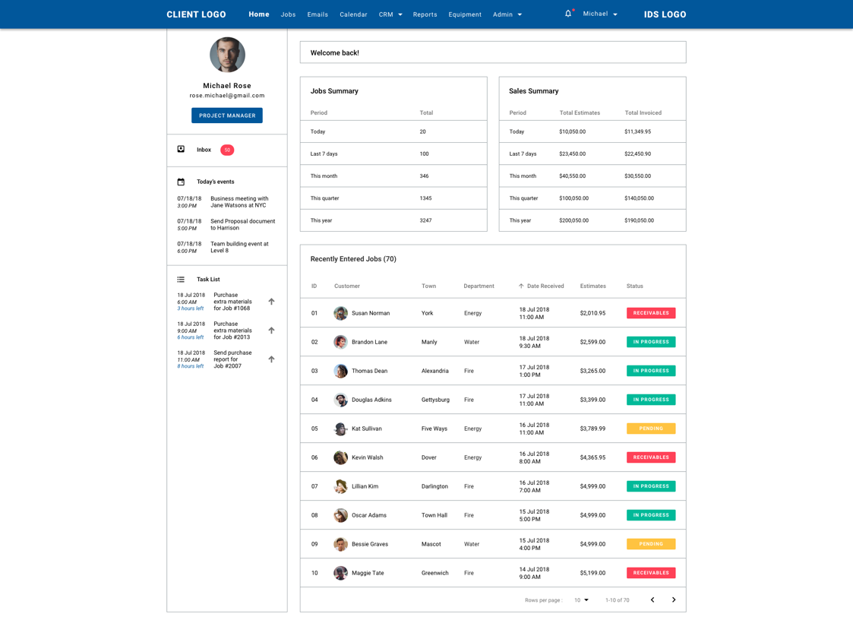

**II) Navigation Menu Bar**

User will be given a nagivation bar on top of each screen throughout the whole system with the following menus:

**Home**:

Displaying *Job Summary*, *Sales Summary* and *Recently Entered Jobs* (those newly added jobs in the last 7 or 15 days period).

**Jobs:**

Displaying *Current jobs* (those jobs with current involvement of the actively signed in user and do not have status of “Pending”) and *Current month’s sales* (those jobs that are completed with status of “Closed”) as well as allowing user to *Create new job*, *Search for jobs*, *View jobs per company*, *employee and department*.

**Emails**:

With configured Gmail account allowing user to perform actions such as check email, compose new email, reply to selected email, forward to others. User can easily check mails from IDS system to notify them of to-do tasks and other activities without having to switch platform. User will be able to view Contact card when click onto a specific Email ID or Email Profile Picture, this information is in accordance with data from either CRM or HRM.

**Calendar**:

With configured Google account (assuming user using same Google account for both Gmail and Calendar), user will be able to search for event/to-do task, view calendar per day, week, month, year and job schedules. Moreover, user can perform tasks which are similar on Google Calendar such as: Add/Modify/View/Remove event, Add/Remove/Rename Active Calendar, Add/Remove Guests to calendar and control how their interaction with the calendar. IDS’s Calendar system is expected to allow user to keep track of start time/end time/logged time/ remaining time for each to-do task assigned to employee.

**CRM**:

Containing 2 sub menus including Residential where all the residential contacts are listed and Commercial in which all the commercial contacts are listed (both customers and vendors).

**Report**:

User will be given a pre-set of Reports (collected from Quickbooks) under *Standard Reports*, user’s customised reports will be saved under *Custom Reports*, and other reports relating to Management and Accounting will be presented under *Management Reports*. User can add their frequently-viewed reports into the section of “Favorites”, furthermore, they can view/export/customise report headers, style, displaying columns however they see fit. Exported reports are presented in Excel format.

**Equipment**:

This screen will display a list of *Available Equipment* and *Unavailable Equipment* and allow user to Add/Edit/Assign Equipment to employee.

**Admin**:

With the following sub menus:

* Account Settings: Edit company information & User profile
* Notifications: Edit notifications settings
* Integrations: Configure Google Account and QuickBooks Desktop
* HRM: Manage Employees

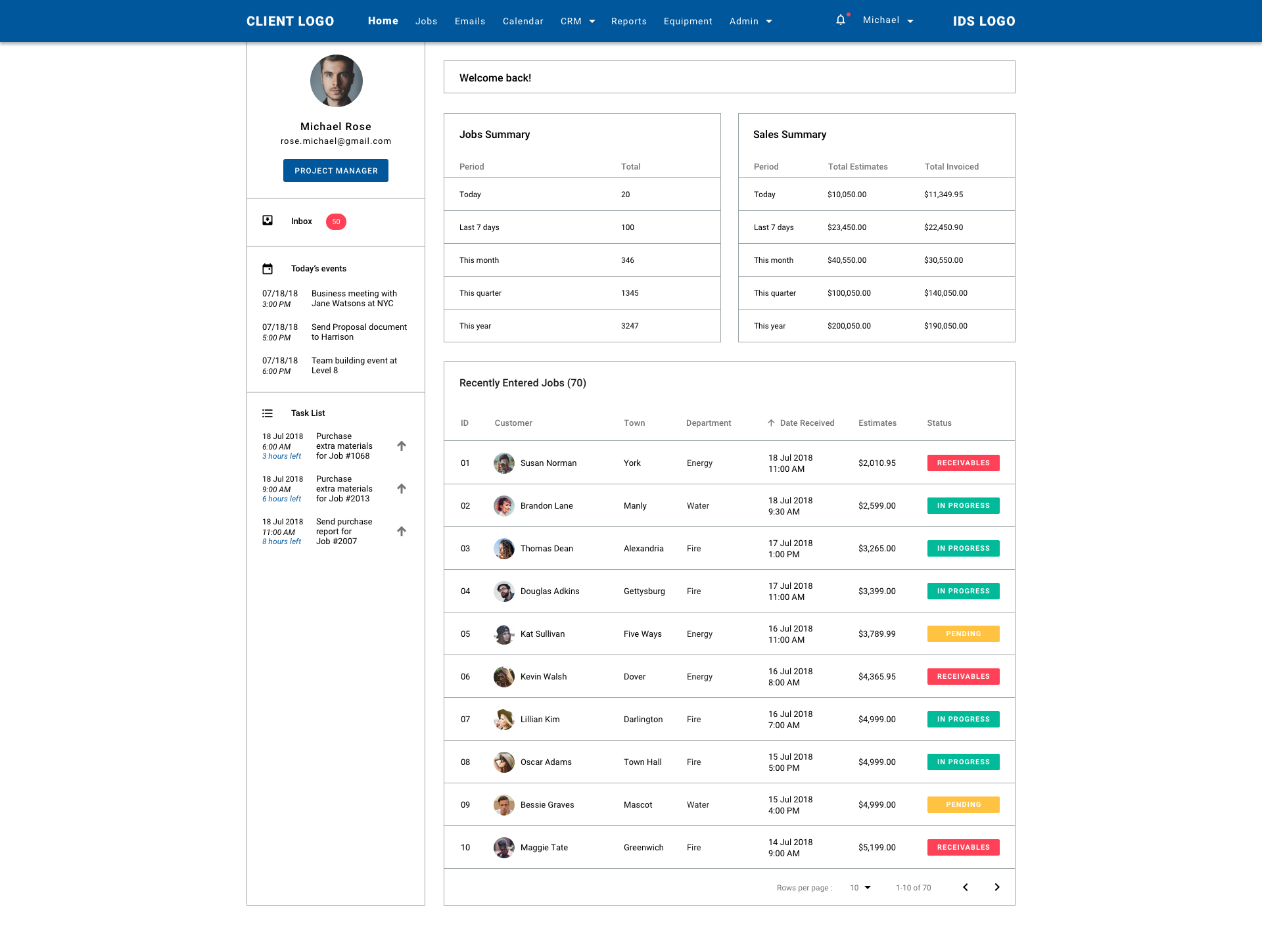

**III) Functions**

**1. Sign Up & Sign In**

Ideally, IDS will introduce a landing page where user can view information showcasing what IDS system is and what it has to offer, those are designed to encourage potential customers to purchase and use the system. However, for the beta version of this web-based application, IDS will temporarily omit landing page. User will find themself a Sign Up & Sign In form.

To become an user of IDS is straight-forward. There are 2 ways for user to start using:

**a) Standard email registration.**

**b) Sign up via Google Account or Facebook account**. Once chosen, IDS will ask for authentication from Google, once the user’s information is verified, user will be required to enter a password which he or she will use to log into IDS for extra security.

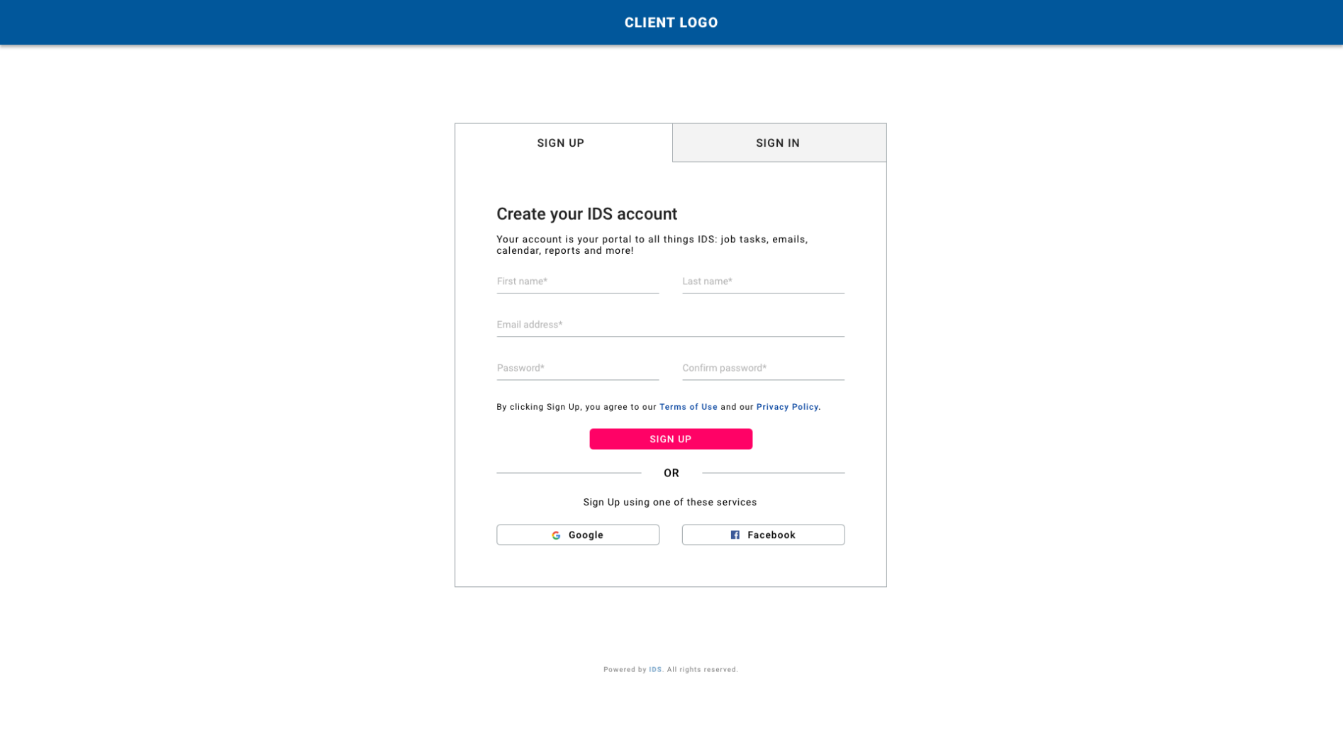

Once registration is done, getting into the system is just a piece of cake. User is only required to enter their registered email and password.

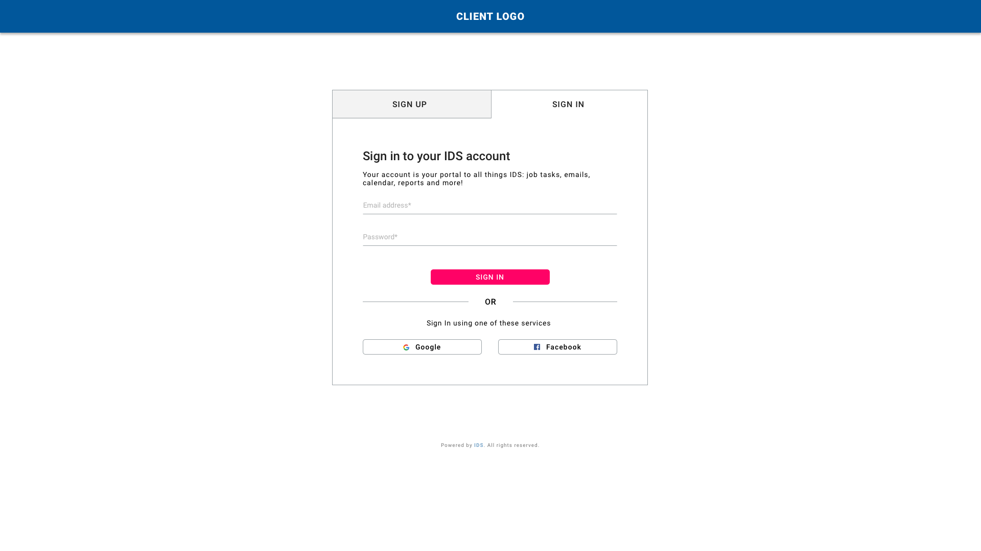

**Prototype Link:**

Sign Up: <https://projects.invisionapp.com/d/main#/console/14757438/316513386/preview>

Sign In: <https://projects.invisionapp.com/d/main#/console/14757438/316513387/preview>

**2. User Roles**

There are 2 distinguished user roles:

**a) Admin**

Admin users will have access to the majority of IDS system, for example:

* Create Job
* Manage Job/Modify Job
* Add Contact/Modify Contact
* Add Employee/Modify Employee
* Customise Company Settings
* Customise Report including Management Report
* Control/Supervise system users’ roles
* Manage Equipment

And other activities of a standard users.

**b) Standard Users**

Standard users have limited to IDS system, for example:

**CAN:**

* View Job Details for any Job (even ones they’re not assigned to)
* Add Job Notes/Journals to any Job
* Add Events or To-do tasks to any Job

**CANNOT:**

* *Cannot* Edit Job details
* *Cannot* Edit existing Job Notes/Journals that are not added by them
* *Cannot* Edit exisiting Events or To-do tasks that are not added by them

Admin user can configure any users’ job titles. Standard user can only modify their job titles. User roles can be multiple, maximum roles can be up to 5.

For example, Michael Rose has 2 job titles: Estimator, Project Manager.

**3. Nagivation Menu**

Permanently locates on top of each screen throughout the system.

Nagivation bar contains the following:

* Client Logo – Customisable via Admin/Account Settings
* Search bar
* Menu tabs

a) Home

b) Jobs

c) Emails (Gmail integrated)

d) Calendar (Google Calendar integrated)

e) CRM with 2 sub menus:

* Residential
* Commercial

f) Reports

g) Equipment

h) Admin with 4 sub menus:

* Account Settings
* Notifications
* Integrations
* Human Resource Management
* Notification Icon
* User Profile Quicklink – Drop down list:
* User Profile
* Notifications
* Log Out
* IDS System Logo

**Prototype Link:**

Nagivation Menu: <https://projects.invisionapp.com/d/main#/console/14757438/307261426/preview>



**4. Global User Column**

The Global User Column will appear on the left of each screen throughout the system.

The column contains:

a) User Avatar

b) User Display Name

c) User Job Title (as tags)

d) Inbox Notification (Gmail integrated)

* Displays Unread emails
* Direct link to Emails default screen

e) Calendar Notification (Google Calendar integrated)

* Displays 3 upcoming events
* Displays Event Name, Event Date, Event Time
* Direct link to the chosen event

f) Task list

* Displays 3 upcoming tasks
* Displays Task Name, Task Date, Task Time, Time remaining until Completion required
* Up/Down Arrrow for user to set Priority of displayed tasks
* Direct link to the chosen task

**Prototype Link:**

Global User Column: <https://projects.invisionapp.com/d/main#/console/14757438/307261426/preview>



**5) Homepage**

Once the user logs into the system, he/she will be directed to the Homepage.

Homepage will display the following:

**a) Jobs Summary**

Data for Jobs Summary will be generated via QuickBooks.

* Today: Total number of jobs owned by the current user for the *current day*.
* Last 7 days: Total number of jobs owned by the current user in the *past 7 days*.
* This month: Total number of jobs owned by the current user for the *current calendar month*.
* This quarter: Total number of jobs owned by the current user for the *current calendar* *quarter*.
* This year: Total number of jobs owned by the current user for the *current calendar* *year*.



**b) Sales Summary**

Data for Jobs Summary will be generated via QuickBooks.

* Today: Total amount of Estimates AND Total amount of Invoices received for the *current day*.
* Last 7 days: Total amount of Estimates AND Total amount of Invoices received for the *last 7 days*.
* This month: Total amount of Estimates AND Total amount of Invoices received for the *current calendar month*.
* This quarter: Total amount of Estimates AND Total amount of Invoices received for the current calendar *quarter*.
* This year: Total amount of Estimates AND Total amount of Invoices received for the *current calendar* *year*.



**c) Recently Entered Jobs**

Display a list of the most recent jobs owned by the current user in reverse chronological order in the last 7 or 15 days, regardless of Job Statuses. Total Number of Jobs in this section will be displayed next to the section Title.

The list of jobs will be display in table format with the following column headers:

* ID: Auto-generated by IDS system
* Customer: Display Customer Avatar and Name
* Town: City associated with the job
* Department
* Date Received: Display date and time in reverse chronological order
* Estimates: Total Estimates received for the specific job to this date
* Status: Job Statuses from Pending, In Progress, Receivables, Closed

User will be able to sort Job ID (ascending order or descending order), Customer Name (A to Z or Z to A) and Date Received (newest to oldest or oldest to newest). Default rows per page is set at 10. View per page is configurable. User can navigate the table using Previous / Next arrows at the table footer.

Clicking onto the row will re-direct user to the chosen job’s details.



**Prototype Link:**

Homepage: <https://projects.invisionapp.com/d/main#/console/14757438/307261426/preview>

**6) Jobs**

User will find information regarding:

**a) Current Jobs**

Display by default a list of the 5 most recent jobs owned by the current user that do not have a status of “Pending” in reverse chronological order. Total Number of Jobs in this section will be displayed next to the section Title.

The list of jobs will be display in table format with the following column headers:

* ID: Auto-generated by IDS system
* Customer: Display Customer Avatar and Name
* Town: City associated with the job
* Department
* Date Received: Display date and time in reverse chronological order
* Estimates: Total Estimates received for the specific job to this date
* Status: Job Statuses from In Progress, Receivables, Closed

User will be able to sort Job ID (ascending order or descending order), Customer Name (A to Z or Z to A) and Date Received (newest to oldest or oldest to newest). Default rows per page is set at 5. View per page is configurable. User can navigate the table using Previous / Next arrows at the table footer.

Clicking onto the row will re-direct user to the chosen job’s details.

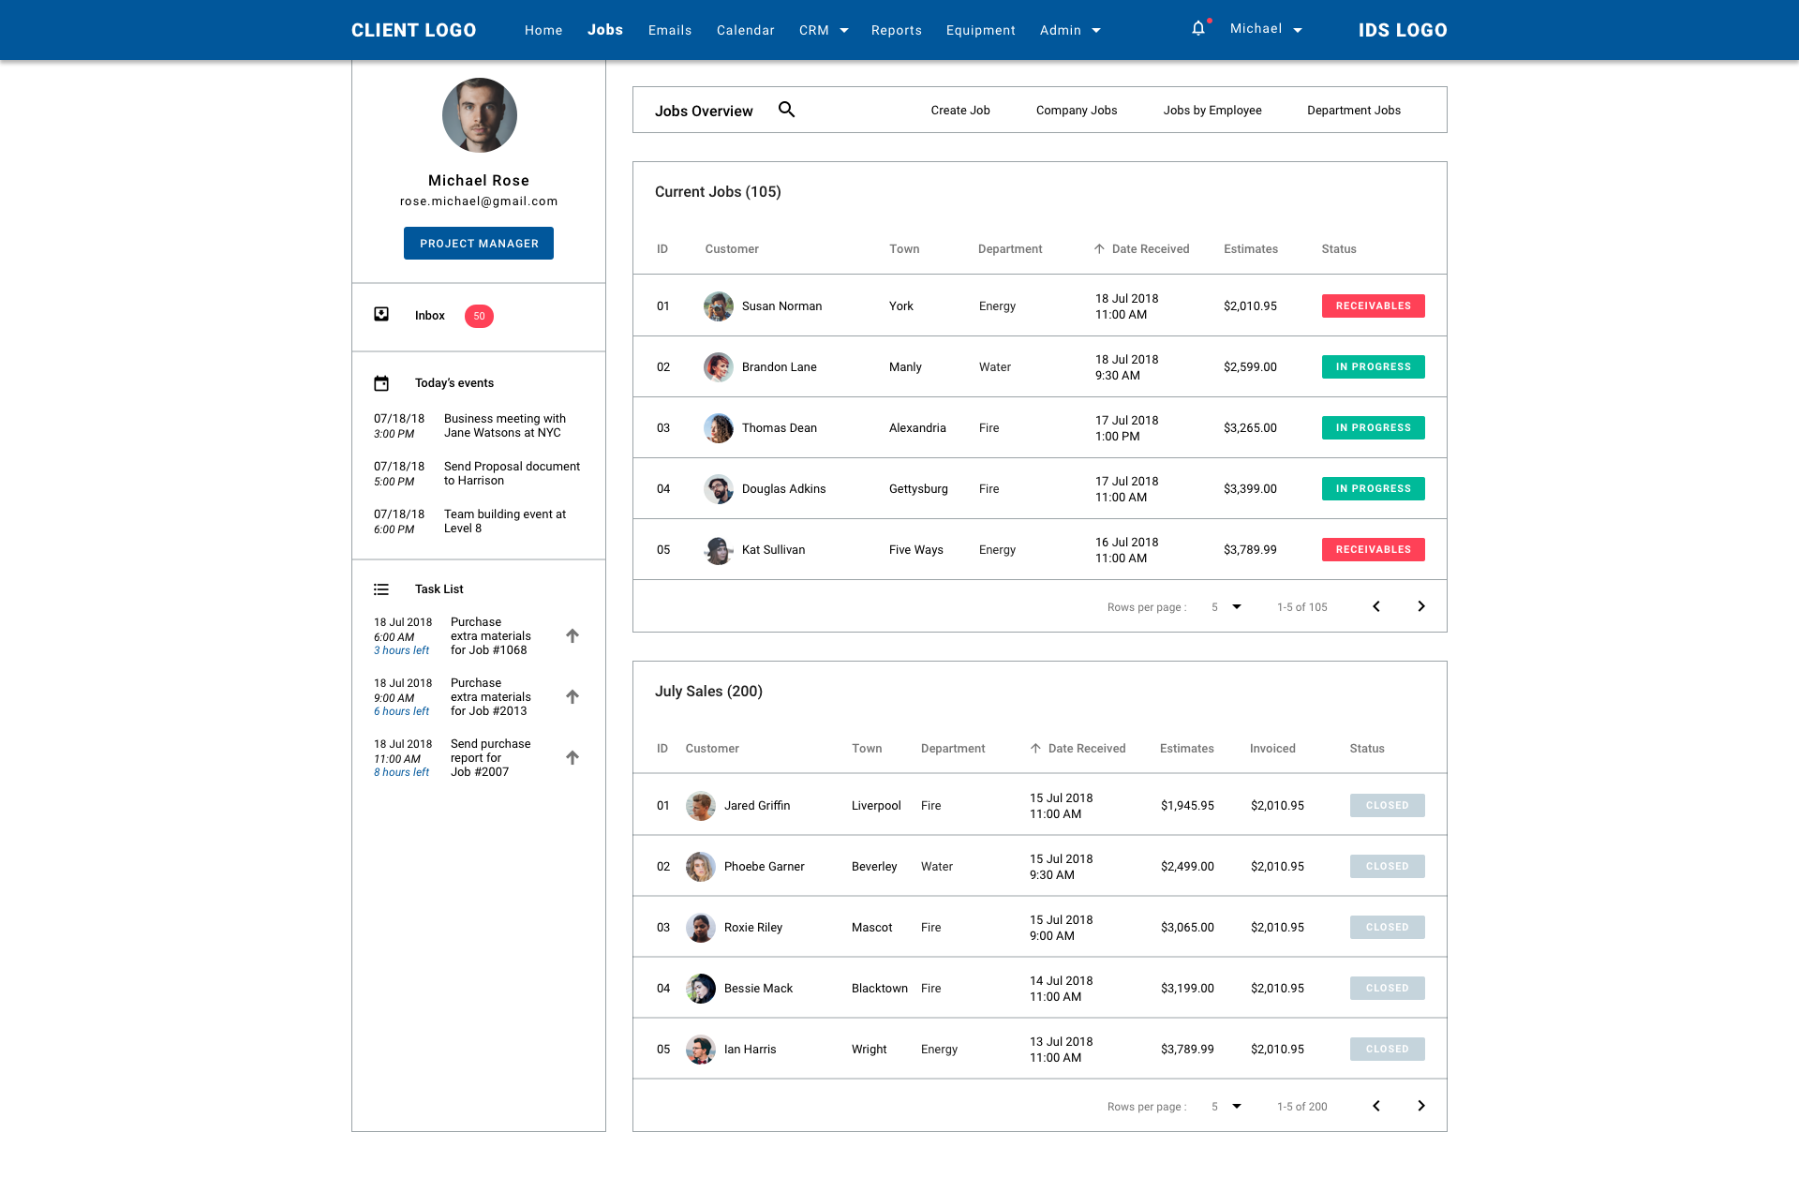

**Prototype Link:**  
Current Jobs: <https://projects.invisionapp.com/d/main#/console/14757438/309837162/preview>

**b) Current Month’s Sales**

Display by default a list of the 5 most recent Sales for the current user, which are jobs that have a status of “Closed” in reverse chronological order. Total Number of Sales in this section will be displayed next to the section Title.

The list of jobs will be display in table format with the following column headers:

* ID: Auto-generated by IDS system
* Customer: Display Customer Avatar and Name
* Town: City associated with the job
* Department
* Date Received: Display date and time in reverse chronological order
* Estimates: Total Estimates received for the specific job to this date
* Invoiced: Total Invoices received for the specific job to this date
* Status: Job Statuses from In Progress, Receivables, Closed

User will be able to sort Sales ID (ascending order or descending order), Customer Name (A to Z or Z to A) and Date Received (newest to oldest or oldest to newest). Default rows per page is set at 5. View per page is configurable. User can navigate the table using Previous / Next arrows at the table footer.

Clicking onto the row will re-direct user to the chosen job’s details.



**Prototype Link:**

Current Month’s Sales: <https://projects.invisionapp.com/d/main#/console/14757438/309837162/preview>

Under Job menu tab, user will be given a Search bar along with the following 4 sub-menus:

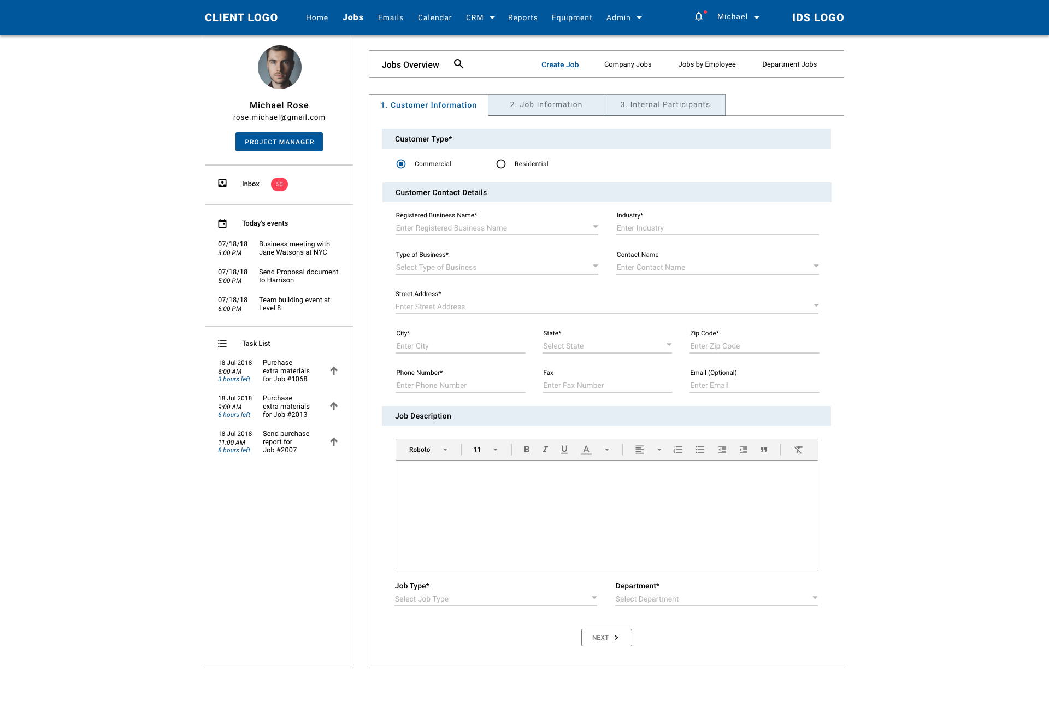

* **Create Job**

User will be required to fill out information divided into 3 seperate steps:

**Step 1: Customer Information**

* Customer Type: Select between “Commercial” or “Residential”
* Customer Contact Details:
* If “*Residential*” is selected,

then user will have to fill out the following:

* Customer Name (required): Add new or Select from CRM
* If Select from CRM, associated Phone number, Email, will be populated.
* Email (optional)
* Phone Number (required)
* Alternative Phone Number (optional)
* Address (required): Street Number, City, State (drop down list – data obtained from Google), Zip Code
* If customer name is selected from CRM, when the user type in the first 3 letters of address, a drop down list will appear, suggesting the associated addresses with the chosen customer, user then click to choose the suitable address. This will determine association link of this newly created jobs with other jobs under the same customer name, differentiated by department.

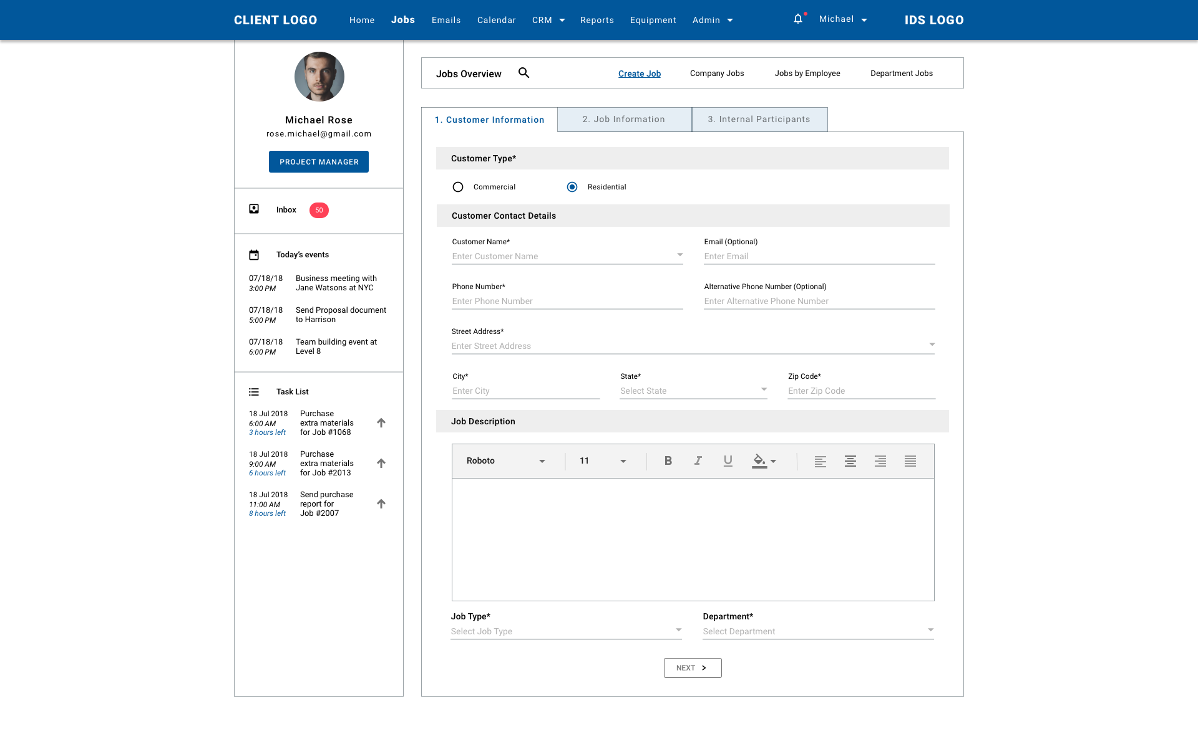

* If “*Commercial*” is selected,

then user will have to fill out the following:

* Registered Business Name (required): Add new or Select from CRM
* If Select from CRM, associated Phone number, Email, will be populated.
* Industry (required): Add new or populated once Select Business from CRM.
* Type of Business (required): Select from Profit, Not-for-profit, Government
* Contact Name (optional): Manual add new or Select from CRM
* Address (required): Street Number, City, State (drop down list – data obtained from Google), Zip Code
* If business is selected from CRM, when the user type in the first 3 letters of address, a drop down list will appear, suggesting the associated addresses with the chosen business customer, user then click to choose the suitable address. This will determine association link of this newly created jobs with other jobs under the same customer name, differentiated by department.



* Phone Number (required)
* Fax (optional)
* Email (optional)
* Job Description (or Initial Job Journal):
* Text area: User can enter initial job journal in provided text area. Tooltip is given for user to format the text however they see fit.
* Job type (required): Select from Insurance Restoration, Energy, Exteriors
* Departments (required): Department is configurable under Admin. Here are some of the examples: Emergency Repairs, Energy, Fire Damage Cleaning & Repairs, Vehicle Impacts, Water Damage Mitigation & Repairs, etc.

Once all the required fields in Step 1 are filled out, user can go to the next step by clicking “Next” button located at the bottom of the form.

**Prototype Link**:

Step 1: <https://projects.invisionapp.com/d/main#/console/14757438/316513388/preview>

**Step 2: Job Information**

* Referred by (required): Add new or Select from CRM or HRM
* Marketing Representative (required): Add new or Select from CRM or HRM
* Job Type:
* If “Insurance Restoration” is selected
* Type of Loss: Select from Property Damage, Fire Damage, Water Damage, Wind/Storm Damage, Vehicle Impact
* Source of Loss: Add Custom or Select from Arson, Chimney, Cigarette, Dishwasher, Dryer, Electrical, Flood, Furnace, Hurricane, Lightning Strike, Methlab, Pipe Break, Plumbing Supply Line, Refrigerator, Roof Leak, Septic/Sewer Backup, Sink, Toilet Overflow, Toilet Supply Line, Tornado, Tree, Vandalism, Washing Machine
* Date of Loss: Select date from Date Picker drop down
* External Job Contacts:
* Insurance Carrier (required): Add new or Select from CRM
* Claim Number (required)
* Insurance Agency (required): Add new or Select from CRM
* Agency Contact (required): Add new or Select from CRM
* Field Adjuster (required): Add new or Select from CRM
* Desk Adjuster (required): Add new or Select from CRM
* Property Management Company (requuired): Add new or Select from CRM
* Mortgage Company (required): Add new or Select from CRM
* Third Party Administrator “TPA”: Add new or Select from CRM

Once all the required fields in Step 2 are filled out, user can go to the next step by clicking “Next” button located at the bottom of the form, or go back Step 1 if encounter incorrect information entered by clicking “Back”.

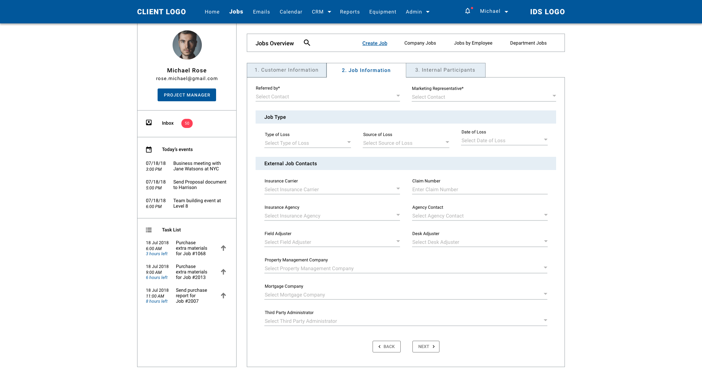

**Prototype Link:**

Step 2: <https://projects.invisionapp.com/d/main#/console/14757438/310923087/preview>

**Step 3: Internal Participants**

* Office (required): IDS Office location (configurable via Admin)
* Supervisor (required): Select from HRM
* Accounting (required): Select from HRM
* Partcipants of corresponding department:
* Estimator: Select from HRM
* Coordinator: Select from HRM
* Department varies depending on which Job Type of selected.

For example, if “Insurance Restoration” is selected, the following Departments will require user to select contacts:

* Water Mitigation Department
* Reconstruction Department
* Contents Department

Once all the required fields in all 3 steps are filled out, user can click “Back” to check if the information is correct or click “Post” to add new job to the system. User will receive a notification as an overlay to let them know that a new job (given auto-generated Job ID) is added successfully. From here, user can discard the notification and start managing the job information in Job Details screen.

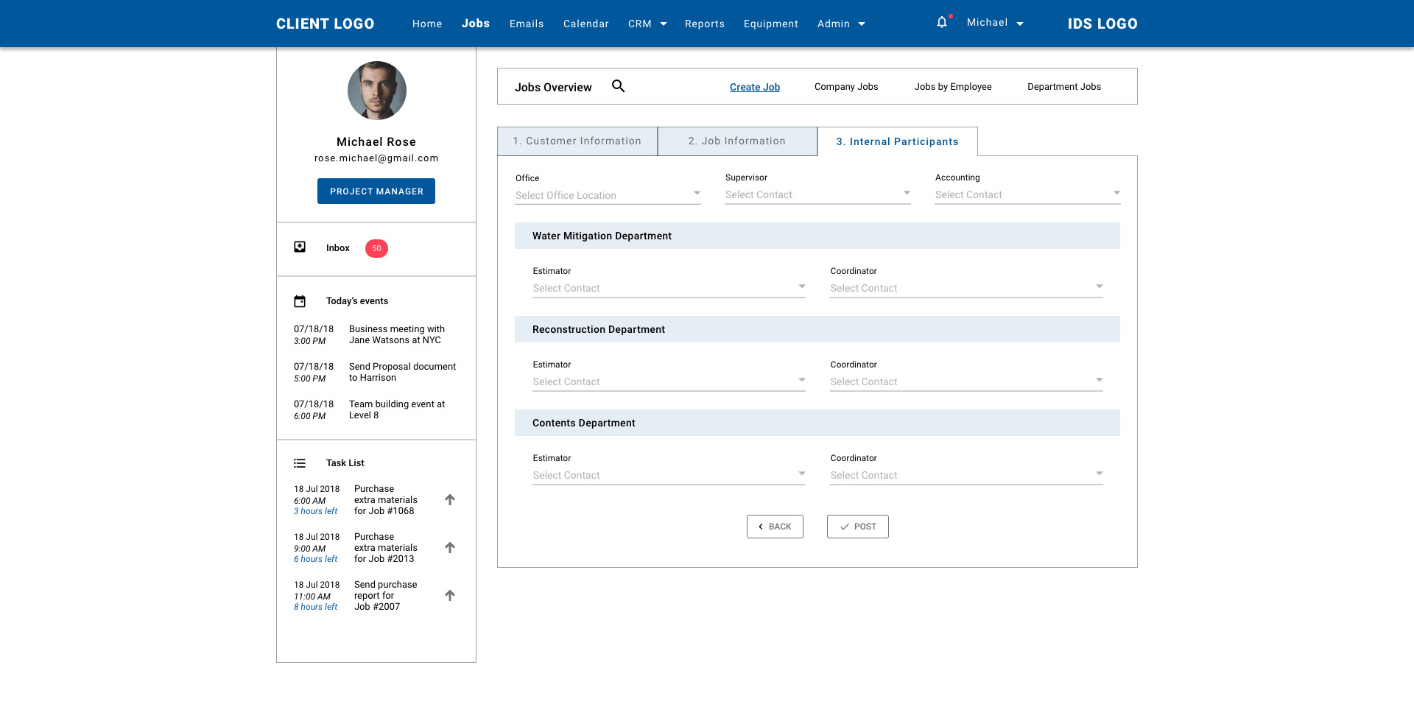

**Prototype Link:**

Step 3: <https://projects.invisionapp.com/d/main#/console/14757438/310705138/preview>

* **Company Jobs**

This screen will display a list of all jobs on IDS system, regardless of job status. Total number of Jobs will be displayed next to section title.

The list of jobs will be display in table format with the following column headers:

* ID: Auto-generated by IDS system
* Customer: Display Customer Avatar and Name
* Town: City associated with the job
* Department
* Date Received: Display date and time in reverse chronological order
* Estimates: Total Estimates received for the specific job to this date
* Status: Job Statuses from Pending, In Progress, Receivables, Closed

User will be able to sort Job ID (ascending order or descending order), Customer Name (A to Z or Z to A) and Date Received (newest to oldest or oldest to newest). Default display is 10 most recent jobs. View per page is configurable. User can navigate the table using Previous / Next arrows at the table footer. Clicking onto the row will re-direct user to the chosen job’s details.

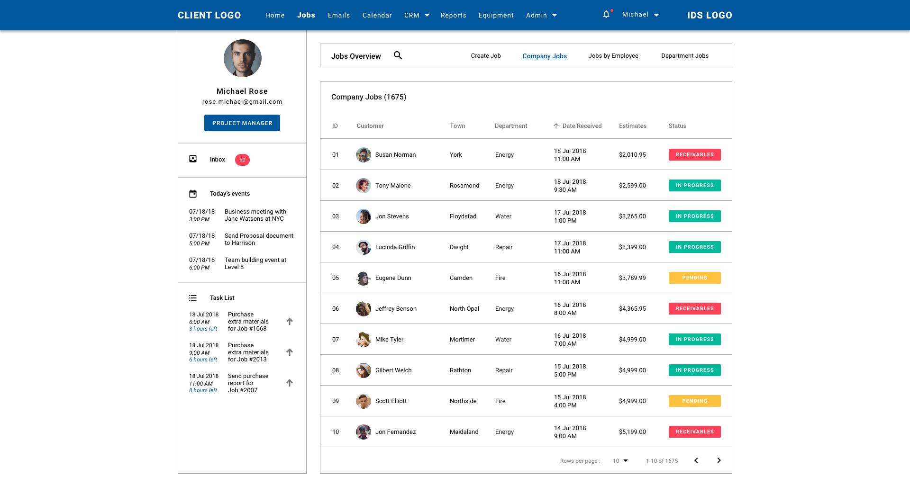

**Prototype Link:**

Company Jobs: <https://projects.invisionapp.com/d/main#/console/14757438/311147450/preview>

* **Jobs by Employee**

This screen will display a list of jobs segmented by Employee, regardless of job status. Total number of Jobs will be displayed next to section title. User will click Expand/Collapse Arrow next to Employee’s Avatar, Name & Title to view jobs segmented by each specific employee. Default display is 10 employees per page. View per page is configurable. User can navigate the table using Previous / Next arrows at the table footer.

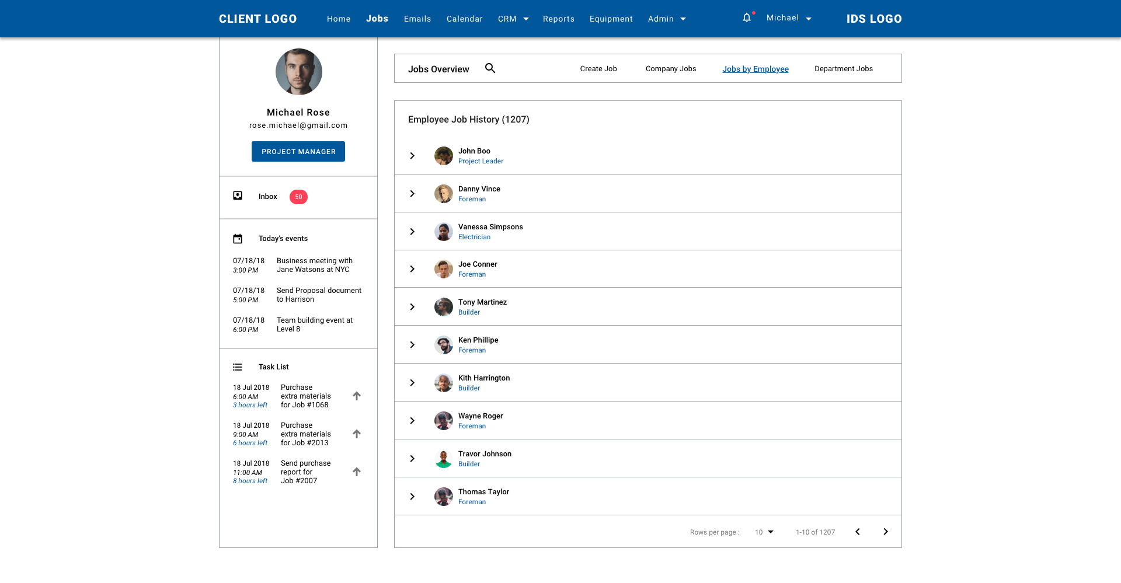

The list of jobs will be display in table format with the following column headers:

* ID: Auto-generated by IDS system
* Customer: Display Customer Avatar and Name
* Town: City associated with the job
* Department
* Date Received: Display date and time in reverse chronological order
* Estimates: Total Estimates received for the specific job to this date
* Status: Job Statuses from Pending, In Progress, Receivables, Closed

User will be able to sort Job ID (ascending order or descending order), Customer Name (A to Z or Z to A) and Date Received (newest to oldest or oldest to newest). Default display is 10 most recent jobs. View per page is configurable. User can navigate the table using Previous / Next arrows at the table footer. Clicking onto the row will re-direct user to the chosen job’s details.

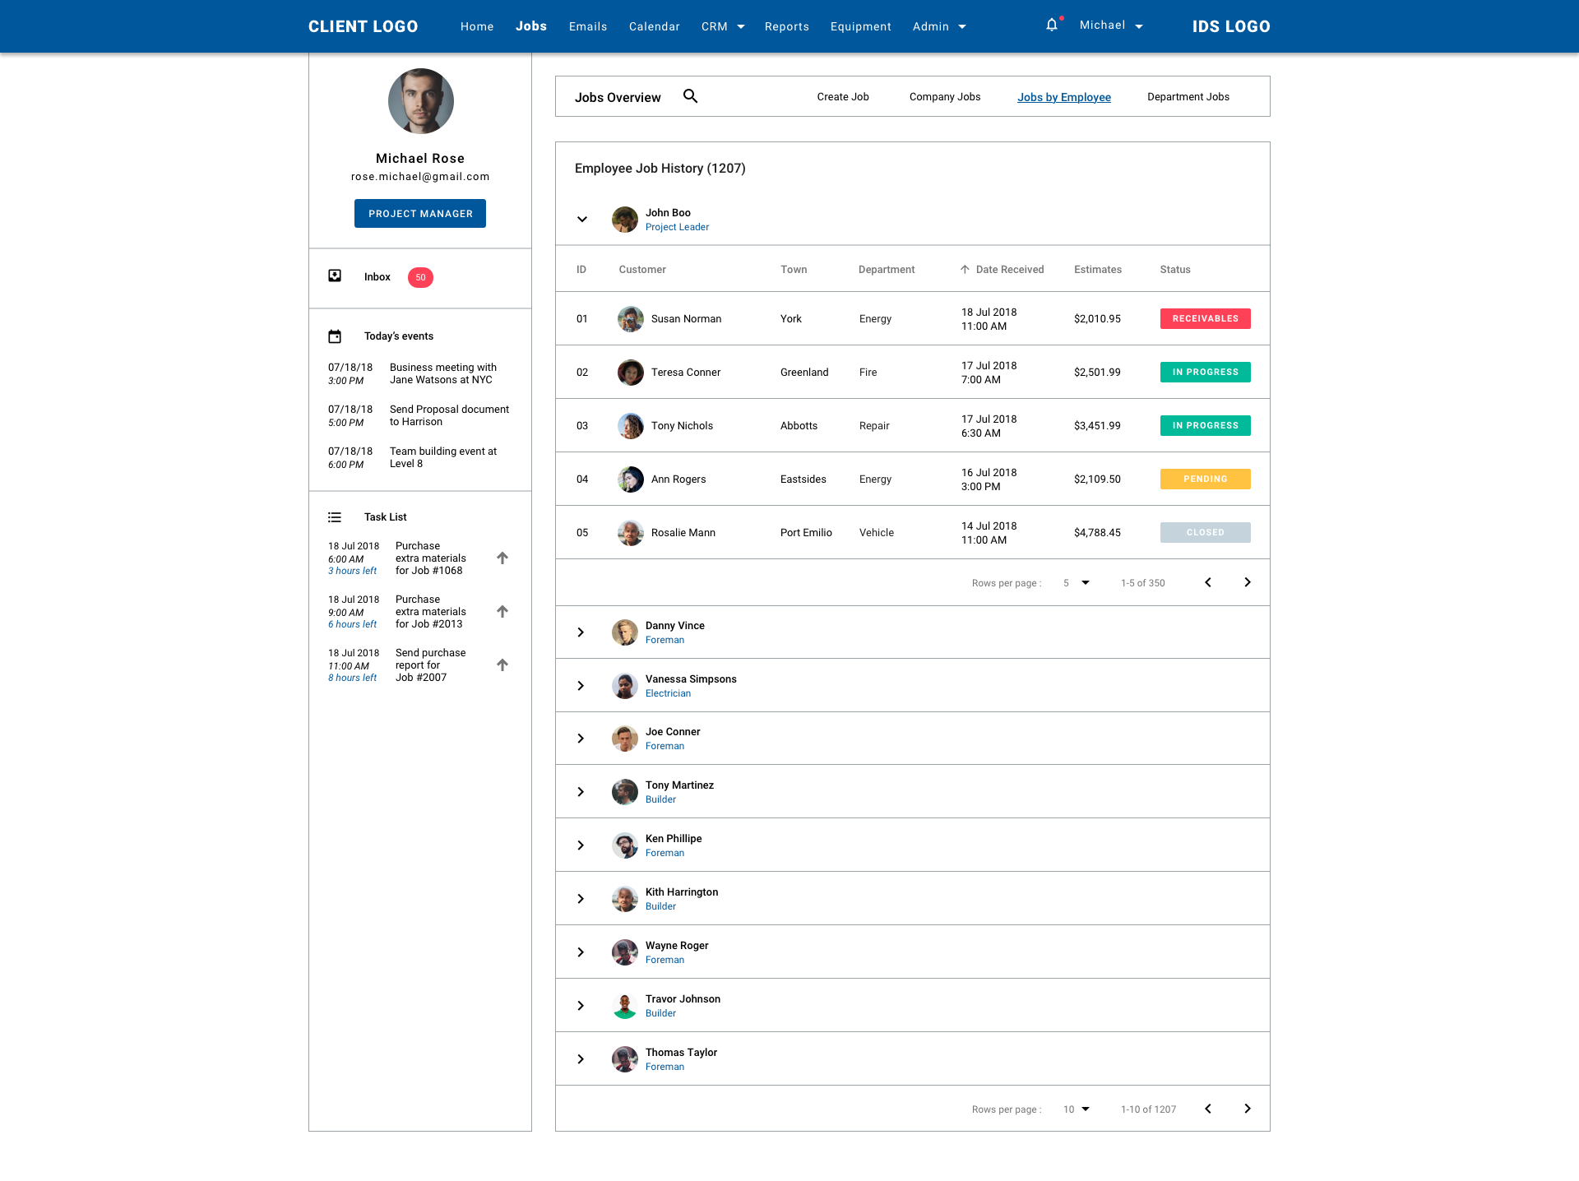

**Prototype Link:**

Jobs by Employee: <https://projects.invisionapp.com/d/main#/console/14757438/311168201/preview>

* **Department Jobs**

This screen will display a list of jobs segmented by Department, regardless of job status. User will click Expand/Collapse Arrow next to Department Name/Description to view jobs segmented by each specific department. Default display is 5 departments per page. View per page is configurable. User can navigate the table using Previous / Next arrows at the table footer.

The list of jobs will be display in table format with the following column headers:

* ID: Auto-generated by IDS system
* Customer: Display Customer Avatar and Name
* Town: City associated with the job
* Department
* Date Received: Display date and time in reverse chronological order
* Estimates: Total Estimates received for the specific job to this date
* Status: Job Statuses from Pending, In Progress, Receivables, Closed

User will be able to sort Job ID (ascending order or descending order), Customer Name (A to Z or Z to A) and Date Received (newest to oldest or oldest to newest). Default display is 10 most recent jobs. View per page is configurable. User can navigate the table using Previous / Next arrows at the table footer. Clicking onto the row will re-direct user to the chosen job’s details.

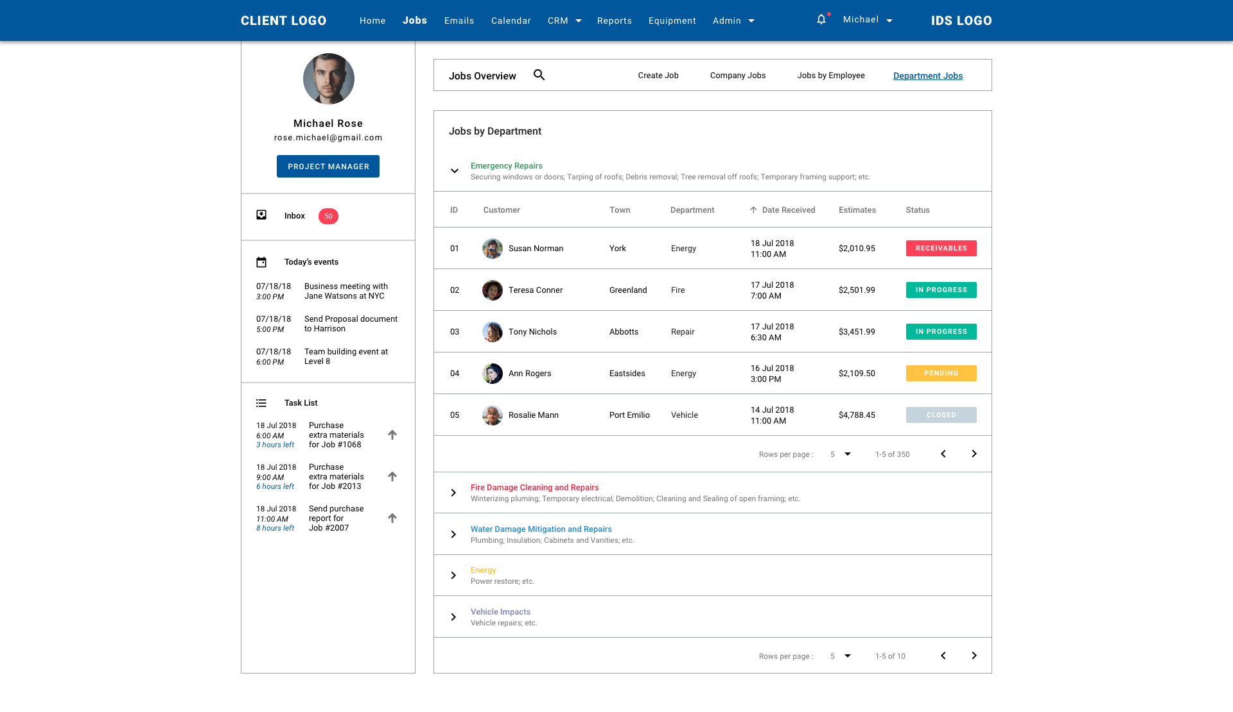

**Prototype Link:**

Jobs by Department: <https://projects.invisionapp.com/d/main#/console/14757438/311181155/preview>

**7) Job Details**

This screen will display job information in accordance with text fields and combo boxes in Create Job screen.

**First section will display:**

* Department
* Claim Number
* Job Status

**Second section will display:**

* Customer information: User can View and Edit
* Customer Type
* Customer Name
* Customer Address: Street, City, State, Zip Code
* Phone number
* Email address
* Map location: User can click map to view in details (Google Map pop-up)
* Job Information: User can View and Edit
* Job Type
* Type of Loss
* Source of Loss
* Date of Loss
* Job Contacts: User can View and Edit
* IDS Office location
* Referred by: Name/Phone
* Marketing Representative: Name/Phone
* Supervisor: Name/Phone
* Accounting: Name/Phone
* Job Participants
* External:
* Insurance Carrier: Name/Phone
* Insurance Agency: Name/Phone
* Agency Contact: Name/Phone
* Field Adjuster: Name/Phone
* Desk Adjuster: Name/Phone
* Property Management: Name/Phone
* Mortgage Company: Name/Phone
* TPA: Name/Phone
* Internal:
* Department 1
* Estimator: Name/Phone
* Coordinator: Name/Phone
* Department 2:
* Estimator: Name/Phone
* Coordinator: Name/Phone
* *Department will varies per job type*
* Job Journals: Any action for the selected job will be recorded in this section. IDS system will automatically record this or user has the ability to manually add in new job journals (that cannot be performed on IDS platform)
* Search function
* Display as table with the following column headers:
* ID
* Date
* Entered by
* Notes
* Sent To
* Job Status: updated once a job journal is added to the job
* Total number of job journals is displayed next to the section title
* View per page is default at 5. User navigates through the table using Previous/Next arrows
* Job Accounting: List related jobs to the currently viewed job focusing on the accounting details. Those are jobs under the same customer/business name AND address, differentiated by department.
* Display as table with the following column headers:
* Job ID
* Department
* Total Approved Estimates
* Total Job Costs
* Total Invoices
* Actual Gross Profit (%)
* Payment Received
* Job Employees: Click arrow to view next employee
* Clicking on each row will re-direct to that job’s details.
* Job Document:

Any document related to the currently viewed job will be shown in this section. There are 3 document categories:

* Files
* Photos
* Contracts
* User can click onto Expand/Collapse arrow to view full list of documents of each category. User can Rename/View Details/Download/Remove each document. IDS system will automatically record the uploaded time of each document. Default view per page is set at 5, navigation uses Previous/Next arrows.

**Prototype Link:**

Job Details (updating): <https://projects.invisionapp.com/d/main#/console/14757438/311481611/preview>

**8) Emails**

IDS system will integrate with Gmail account to allow user to directly check & replay to emails, and many more other actions to their inbox without switching between platforms.

However, Emails tab will only be actively for use once the user configure their Gmail account to the system. In order to do so, user needs to navigate to Admin/Integration/Gmail Account to check if he/she has added an account in. In the case of no Gmail account is configured, user is required to add in an account by clicking on the Text link: “Configure” to be directed to Google authentication site, from then, sign in and once it is successful, user will be re-directed back to IDS system.

To go to an user’s inbox, there are 2 ways:

a) Click Inbox in Global User Column.

b) Click Emails on Navigation Menu bar.

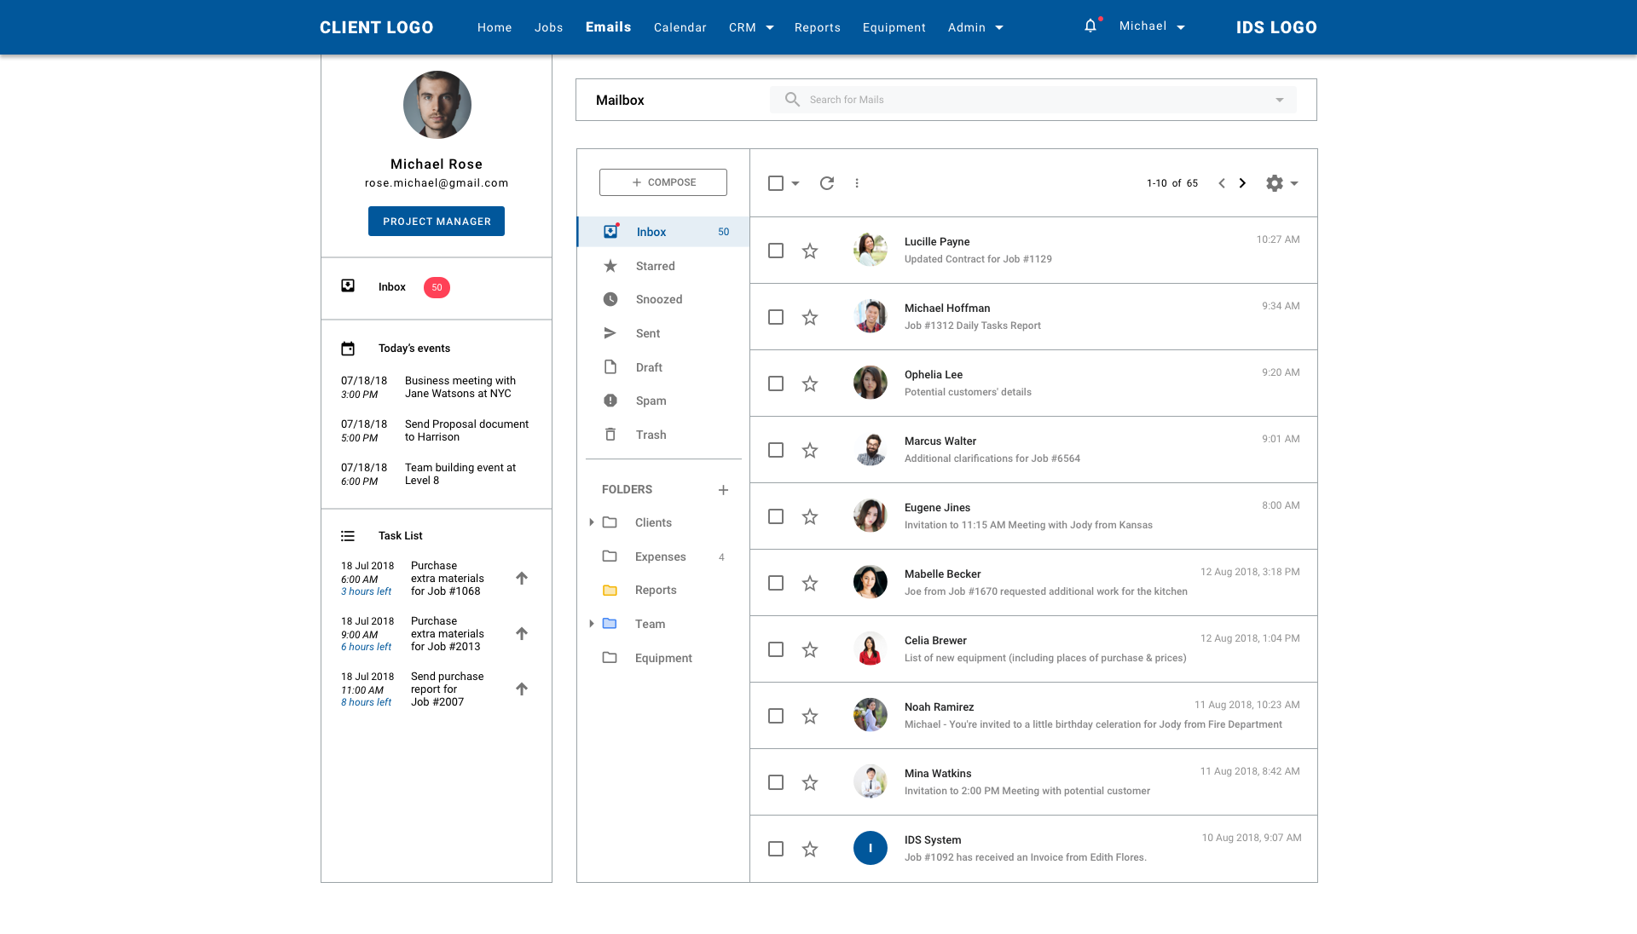

User will see a familiar layout following Google design for Gmail.

* Mailbox Title and Search bar
* Compose button on the left side. Users are given a side-bar menu options of: Inbox, Starred, Snoozed, Sent, Draft, Spam, Trash. Moreover, user can add/rename/remove folder to organise their emails.
* Compose Pop up has basic features such as: Recipient, CC, BCC, Subject, Send Button, Text format, Attachment, Link, Emoji, Image, Delete.

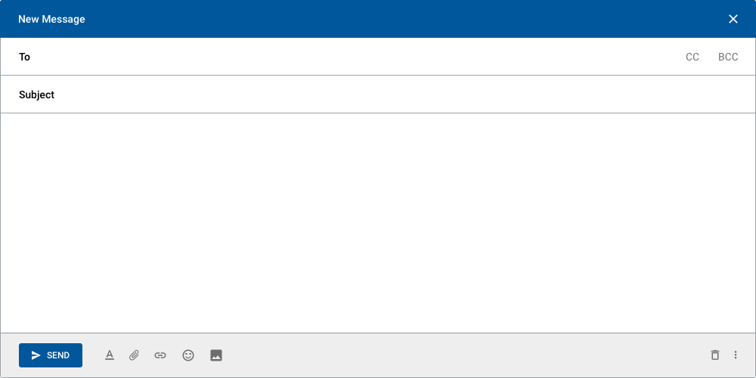

* List of emails will be displayed on the right side. Click onto an email to view its in details, email might contains several conversations, so user can expand by clicking to a specific conversation, otherwise, conversation list will be collapsed. Lastest conversation in the email details view is expanded at default.

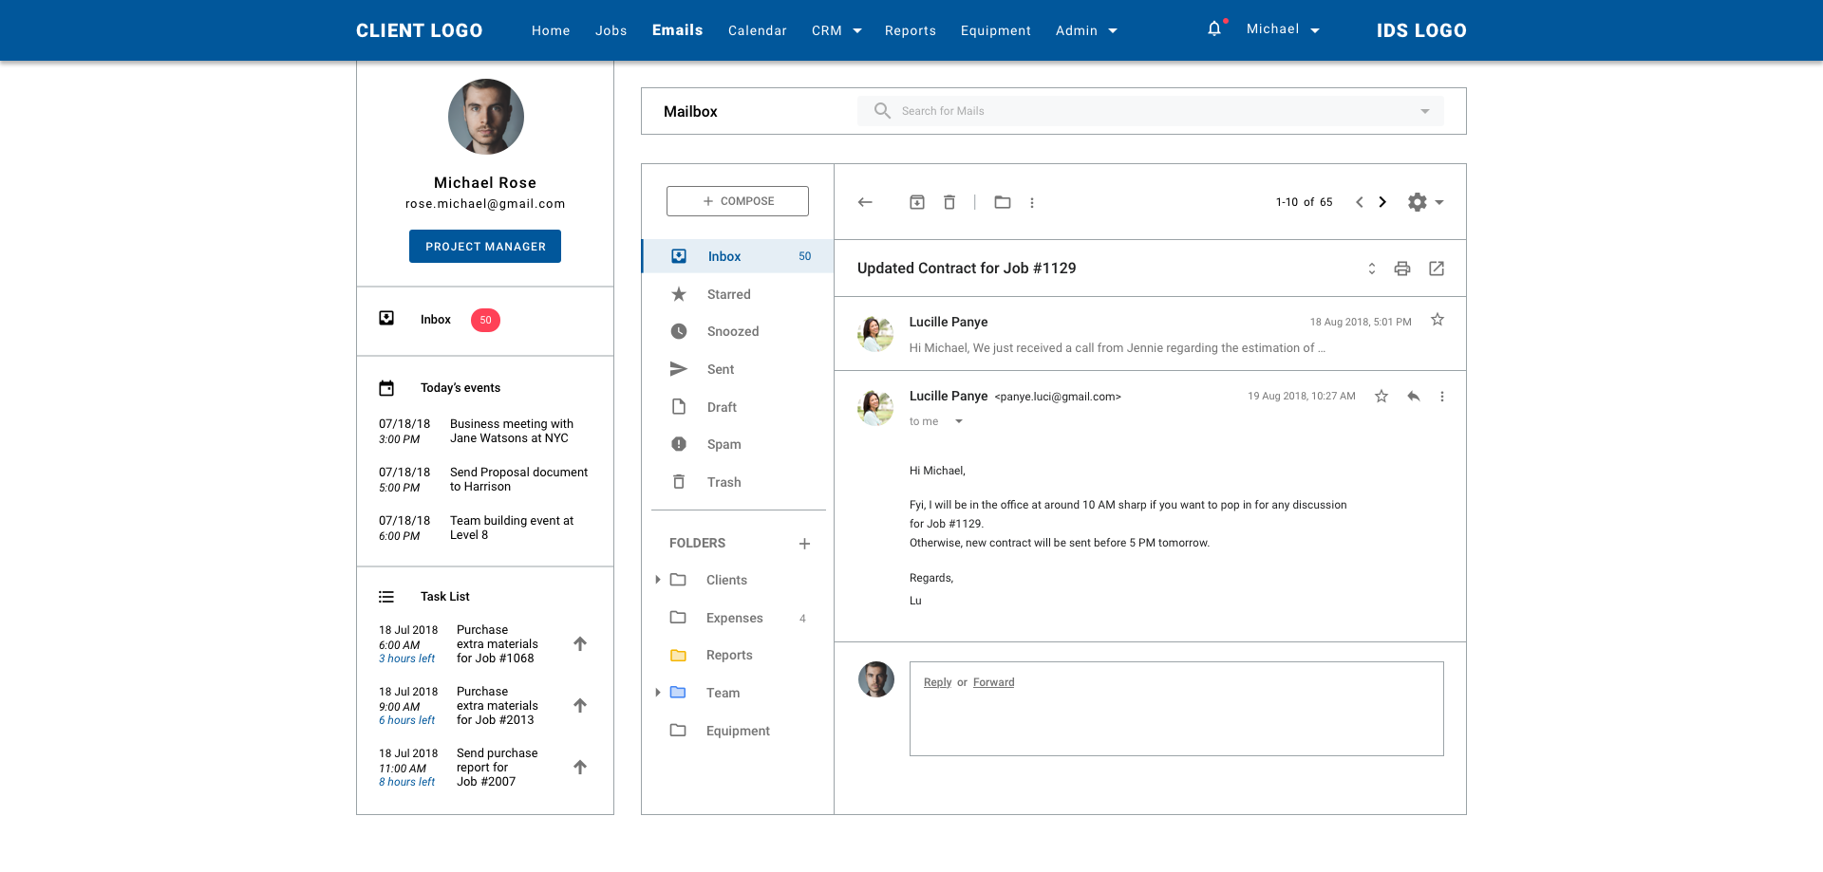

* User can Star their favorite emails by clicking the Star icon.
* User can Reply and Forward emails.
* Once an email is selected, user is given options such as:
* Archive
* Report as Spam
* Delete
* Move to folder
* Label
* Mask as Unread
* Mark as important
* Add to Tasks
* Add star
* Create event
* Filter messages like these
* Mute
* Other setting such as: Inbox settings, Accounts and import, advanced once chosen will direct user to Gmail platform.
* Job journal will be sent as email to notify user of the action. This type of email will follow IDS system’s template. User can view the email in details and be directed to the specific job mentioned in the email by clicking “View Details” button (or text link).
* User can click onto any Avatar, Email Address/Name Display to view a Contact card pop up (data obtained from CRM/HRM if available). User will be directed to the Contact’s full details once clicking “Details” text link.

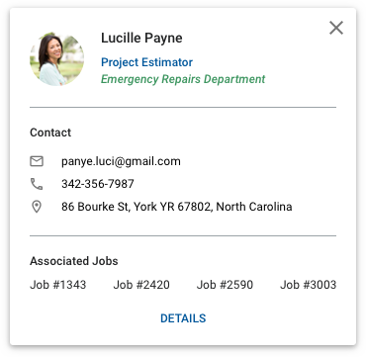

**Prototype Link:**

Default Inbox: <https://projects.invisionapp.com/d/main#/console/14757438/313321940/preview>

Compose: <https://projects.invisionapp.com/d/main#/console/14757438/315267324/preview>

**9) Calendar**

This will be another integration with Google. IDS will follow a layout similar to Google Calendar.

* Search function
* Minimised Current calendar month view
* Active Calendars: Add/Remove/Customise Colour/Name
* Guests: User can Invite/Remove guest to work on specific calendar.
* Calendar view by Day, Week, Month, Year
* User can Add/Edit/Remove Event/Task to specific Job and send Notification to specific employee.
* Event title
* Date, Start time/End time, Time region
* Repeat options
* Event details:
* Event type: Select from Event, Job Task
* Location
* Notification type: Pop up notification, Emails, Time to notify
* Calendar
* Description
* If Job Task is selected, additional fields to fill out:
* Job: Select from Job list
* Employee: Select from HRM. (*Need to confirm multiple selection for this*). Selected Employee will be notified either through notifications or emails.
* Guests: Add/Remove guests and Control what they can do: Modify event, Invite Others, See member list
* *[In Discussion] Calendar is expected to have a Timekeeping function similar to Tsheets*

Reference: <https://www.youtube.com/watch?v=5NX_QZ1AfIw>

* Admin user will be able to log time for multiple employee for a specific Job
* Standard user will be able to log time for himself for a specific Job
* User will be able to view Start Time/End Time/Remaining Time for a specific Job
* GPS tracking via mobile device (*To be confirmed*)

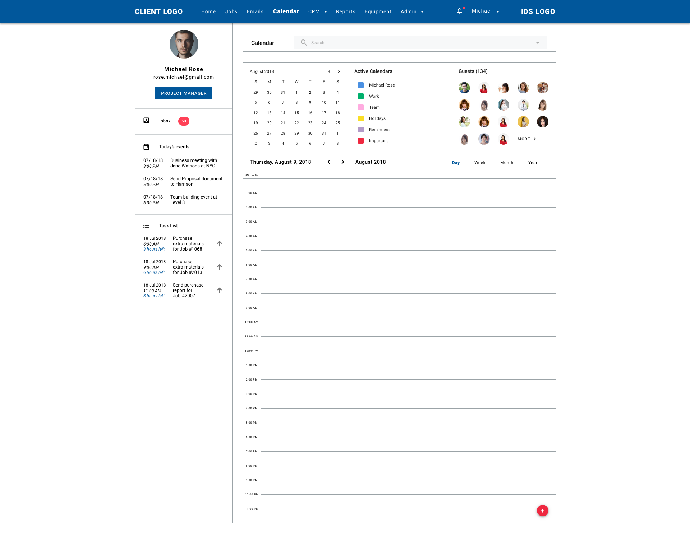

**Prototype Link:**

Calendar: <https://projects.invisionapp.com/d/main#/console/14757438/313573027/preview>

**10) Customer Relationship Management (CRM)**

**a) Residential**

**Prototype Link:** <https://projects.invisionapp.com/d/main#/console/14757438/315270798/preview>

- List all the residential contact who are either a customer OR a vendor to the business.

- Default display:

* Screen title and total number of contacts
* Search function
* Add new button

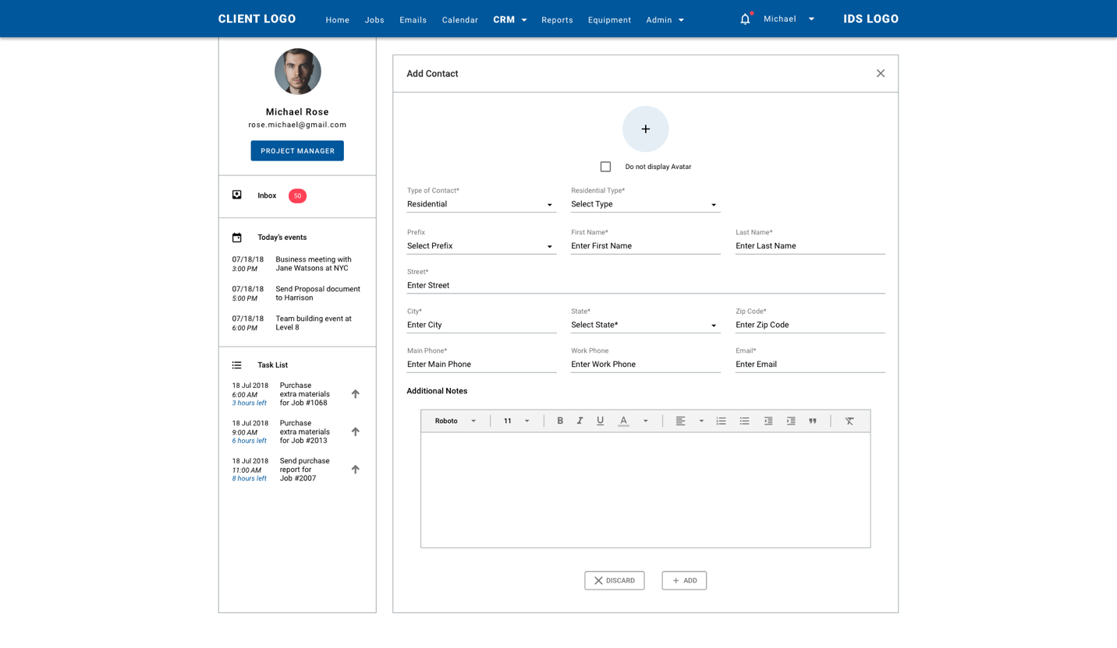

* Scree title
* Discard (X) icon
* Add avatar with “Do not display Avatar” checkbox option
* Type of Contact: required, Residential OR Commercial
* Type of Residential Contact: required, Customer OR Vendor
* Prefix: optional, Mr, Mrs, Ms
* First Name: required
* Last Name: required
* Address: required, Street, City, State, Zip Code
* Main Phone: require, mobile or landline
* Work Phone: optional, mobile or landline
* Email: *needs to confirm optional or required*
* Notes: optional, with text tooltip
* Buttons: Discard, Add
* Table display:

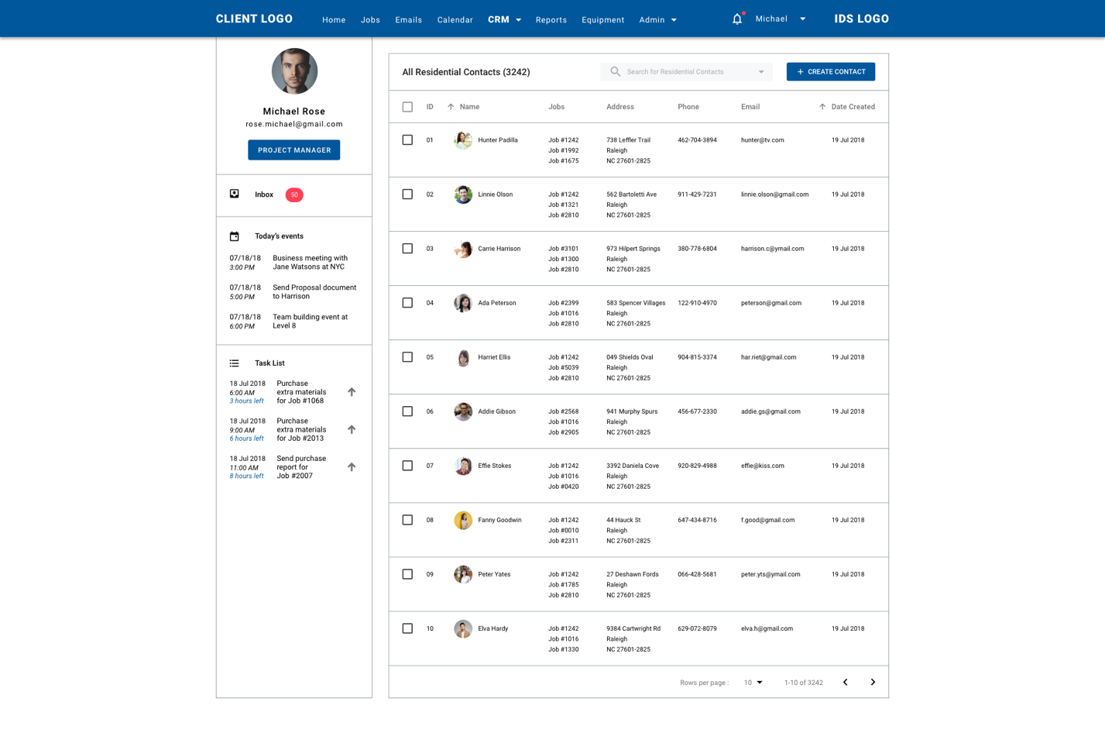

* Checkbox: if selected, row data can be export OR delete
* ID: auto-generated by the system, sort ascending OR descending
* Avatar & Name: sort Name alphabetically OR vice-versa
* Associated Jobs: list all jobs under customer’s name
* Address: list all addresses under customer’s name, can be multiple
* Phone: list phone number under customer’s name, unique value
* Email: list email under customer’s name, unique value
* Date created: auto recorded by the system, sort oldest-newest OR newest-oldest
* Footer: Rows per page (default at 10, customisable), total rows, previous and next arrows
* View Row details

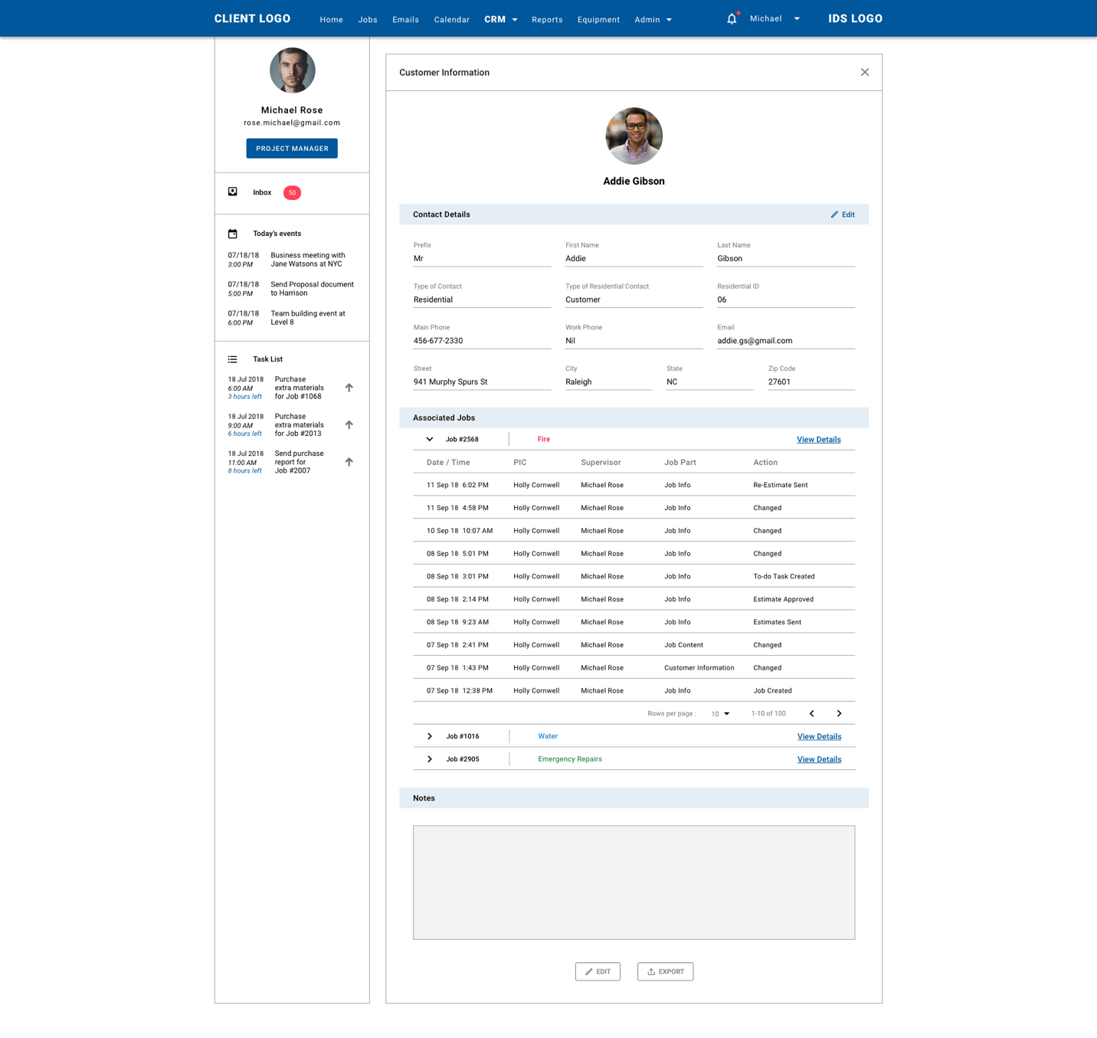

* Avatar: editable
* Contact Name: editable
* Prefix: editable from Mr, Mrs, Ms
* First name: editable
* Last name: editable
* Type of Contact: editable from Residential OR Commercial
* Type of Residential Contact: editable from Customer OR Vendor
* Residential ID: auto generated by system, unique value
* Main Phone: editable, check duplication, unique value
* Work Phone: editable, optional
* Email: editable 🡪 *needs to confirm with Jan: required or optional*
* Address (Street, City, State, Zip Code): editable, multiple values, check duplication
* Associated jobs: Expand OR Collapse arrows to see list of Job journals, Job ID (*needs to confirm with Jan: Job Name*), Department, View Details text link
* Notes: editable
* Buttons: Edit, Export, Discard (X)

**b) Commercial**